**Project Report Titles**

**India’s Agricultural Crop Production Analysis (1997-2021)**

**INTRODUCTION:**

**\*Overview:**

Agricultural crop production refers to the process of growing and harvesting plants for various purposes, including food, fiber, and fuel. It is a vital sector of the global economy and plays a crucial role in providing sustenance for human populations.

Crop production involves several stages, starting with land preparation, which includes activities such as plowing, leveling, and fertilizing the soil. Next, farmers select and plant suitable crop varieties based on factors like climate, soil type, and market demand. Throughout the growing season, they monitor and manage the crops by providing water, controlling pests and diseases, and applying fertilizers or pesticides as needed.

Once the crops reach maturity, they are harvested using different methods depending on the crop type. Some crops, like grains or fruits, are mechanically harvested using specialized machinery, while others, such as vegetables or flowers, may require manual labor. After harvesting, the crops are often processed or stored to maintain their quality and extend their shelf life.

**\*purpose:**

The purpose of agricultural crop production is to provide food, fiber, and fuel for human populations. It is a fundamental sector of the global economy and plays a crucial role in ensuring food security and supporting rural livelihoods. Additionally, crop production contributes to economic development by generating income and employment opportunities. By producing crops, farmers meet the basic needs of communities and contribute to the overall well-being and sustenance of society.

**PROBLEM DEFENITION AND DESIGN THINKING**

1. **Empathy map:**

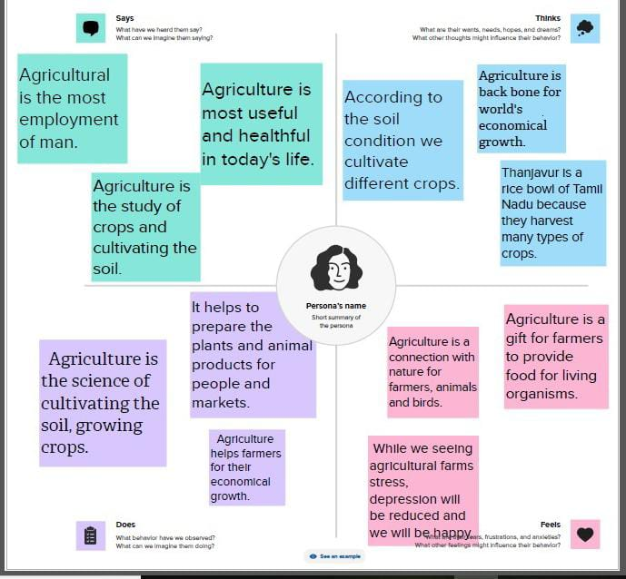

1. **Ideation and Brainstorming map:**

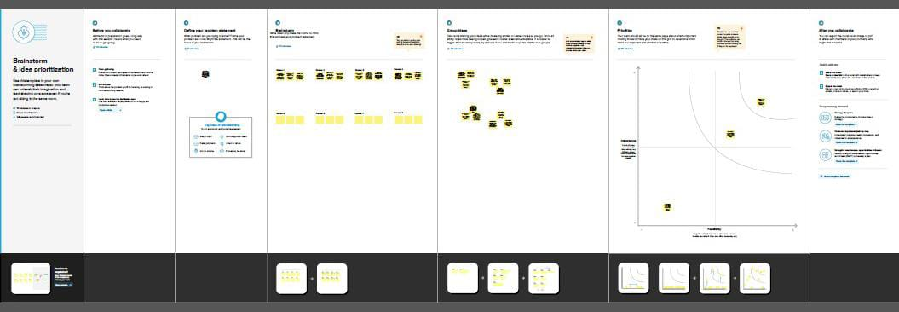

1. **Result:**

We created the data visualization such as dashboard and story using the dataset provided.

**DASHBOARD:**

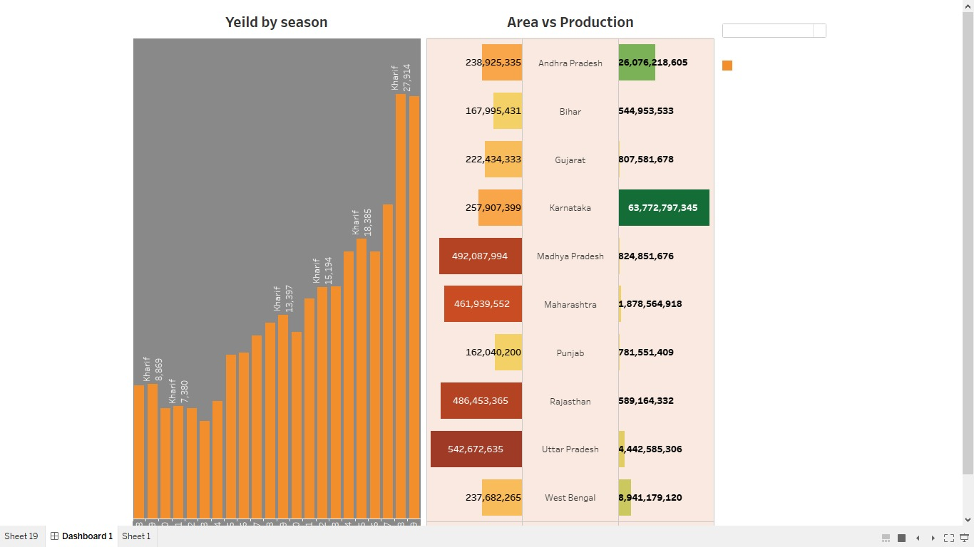

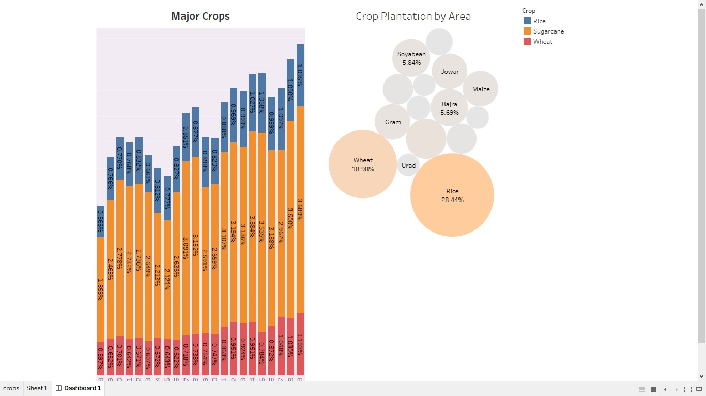

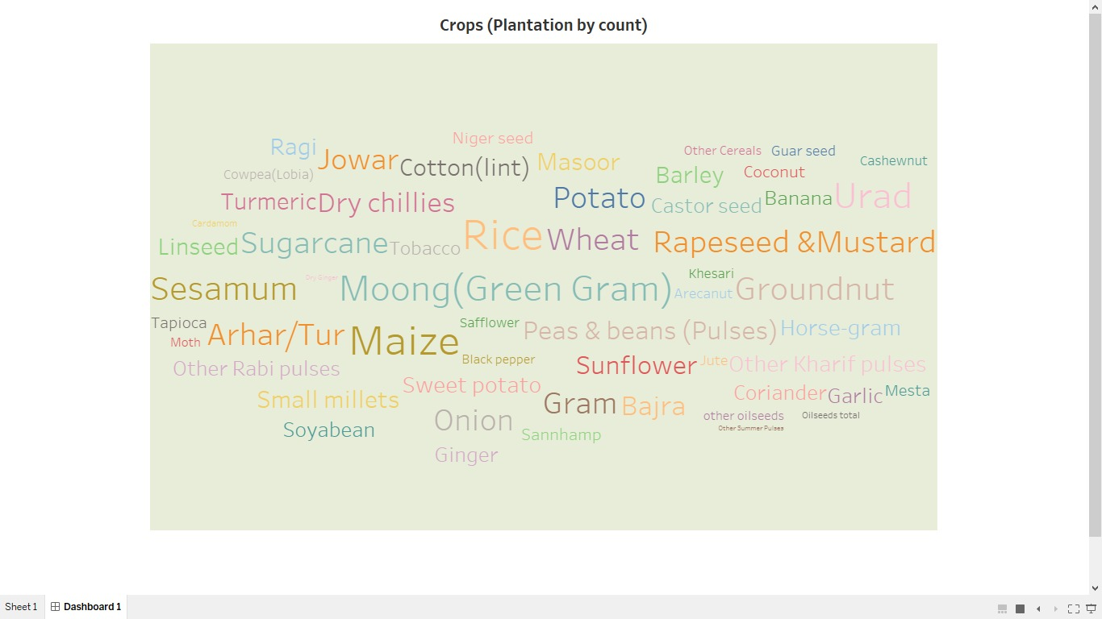

**STORY:**

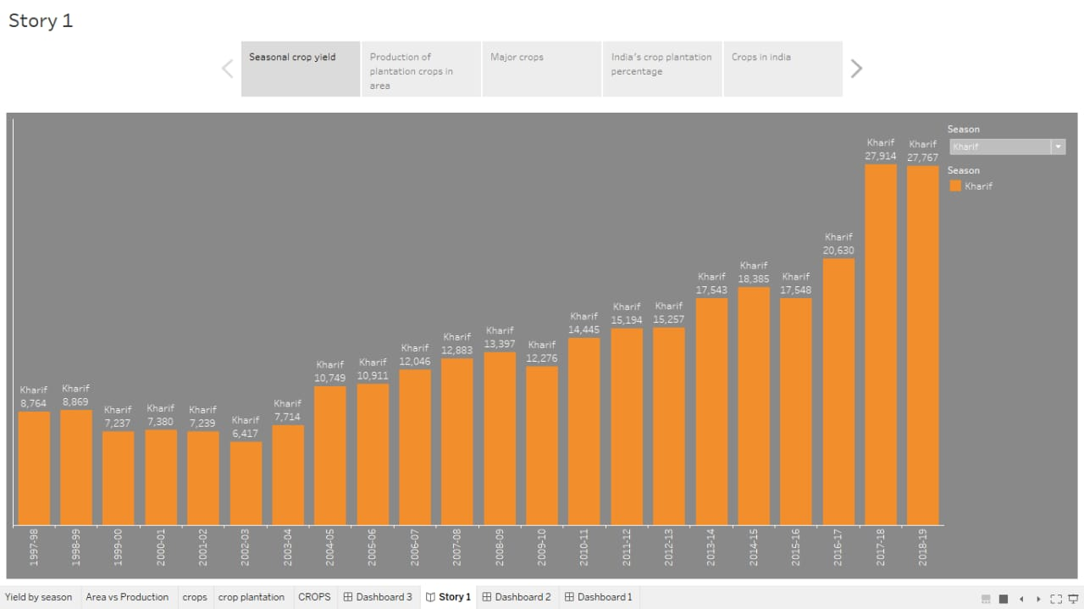

1. **ADVANTAGES AND DISADVANTAGES:**

**ADVANTAGES:**

1. Food Security: Crop production ensures a stable and consistent food supply, reducing the risk of hunger and malnutrition. It allows for the production of a variety of crops, providing a balanced diet and meeting the nutritional needs of populations.

2. Economic Growth: Agriculture contributes significantly to the economic development of countries. Crop production creates employment opportunities, especially in rural areas where agriculture is the primary source of income. It also generates income for farmers and stimulates local economies through trade and market activities.

3. Environmental Sustainability: Sustainable crop production practices promote soil health, biodiversity conservation, and water management. By adopting techniques such as crop rotation, organic farming, and precision agriculture, farmers can minimize the use of chemicals and reduce environmental pollution.

4. Rural Livelihoods: Crop production provides livelihood opportunities for millions of people living in rural areas. It allows farmers to earn a living by cultivating crops and selling them in local or global markets. This helps to alleviate poverty and improve the standard of living in rural communities.

5. Energy and Fuel: Certain crops, such as corn and sugarcane, can be used as a source of biofuel production. This reduces reliance on fossil fuels, promotes renewable energy sources, and contributes to mitigating climate change.

6. Trade and Export: Crop production enables countries to participate in international trade and export their surplus produce. This not only generates foreign exchange earnings but also strengthens diplomatic and economic relations between nations.

7. Innovation and Technological Advancements: Crop production drives innovation in agricultural technologies and practices. Farmers constantly seek ways to improve crop yields, efficiency, and sustainability through the adoption of new farming techniques, machinery, and biotechnology.

8. Cultural Preservation: Traditional crop production methods often involve indigenous knowledge and practices that have been passed down through generations. By preserving these practices, crop production helps to maintain cultural heritage and diversity.

9. Climate Change Adaptation: Crop production can contribute to climate change adaptation by diversifying crops and adopting resilient farming practices. This helps farmers cope with the impacts of climate change, such as extreme weather events and changing growing seasons.

10. Social Stability: A well-functioning agricultural sector can contribute to social stability by reducing rural-urban migration and providing employment opportunities in rural areas. It helps to maintain balanced regional development and prevents overcrowding in urban centers.

**DISADVANTAGES:**

1. Environmental Degradation: Intensive crop production can lead to soil erosion, water pollution, and deforestation. The use of chemical fertilizers and pesticides can harm ecosystems and contribute to the loss of biodiversity.

2. Water Scarcity: Crop production requires significant amounts of water, which can strain water resources in regions already facing water scarcity. Irrigation practices can deplete groundwater sources and lead to the drying up of rivers and lakes.

3. Dependency on External Inputs: Modern crop production often relies heavily on synthetic fertilizers, pesticides, and genetically modified seeds. This can create a dependency on external inputs, making farmers vulnerable to price fluctuations and market forces**.**

4. Food Safety Concerns: The use of chemicals in crop production can raise concerns about food safety and the presence of pesticide residues in crops. Improper handling and storage practices can also lead to contamination and food borne illnesses.

5. Land Degradation: Continuous cultivation of crops without proper soil management practices can degrade soil quality, leading to reduced fertility and productivity. This can result in the need for additional land conversion to meet agricultural demands.

6. Income Inequality: Large-scale commercial farming often dominates the agricultural sector, leaving small-scale farmers with limited access to resources and markets. This can contribute to income inequality and hinder rural development.

7. Loss of Traditional Farming Practices: Modern crop production methods may displace traditional farming practices that are more sustainable and culturally significant. This can lead to the loss of traditional knowledge and cultural heritage.

8. Genetic Erosion: The focus on high-yielding crop varieties can lead to the loss of genetic diversity, as traditional crop varieties are replaced by commercially viable ones. This reduces resilience to pests, diseases, and climate change.

9. Exploitation of Labor: In some cases, crop production relies on cheap labor, leading to poor working conditions, low wages, and exploitation ofagricultural workers, particularly in developing countries**.**

10. Market Volatility: Crop production is subject to market fluctuations and price volatility, which can affect farmers' incomes and livelihoods. Dependence on a single crop can make farmers vulnerable to changes in demand and global market conditions.

**5. APPLICATIONS:**

1. Sustainable Farming Practices: Implementing sustainable farming practices, such as crop rotation, organic fertilizers, and integrated pest management, can help mitigate environmental degradation and preserve soil health.

2. Efficient Water Management: Adopting efficient irrigation techniques, such as drip irrigation and rainwater harvesting, can reduce water consumption and minimize the strain on water resources.

3. Diversification of Crops: Encouraging the cultivation of a diverse range of crops can reduce dependency on external inputs and enhance resilience to market fluctuations.

4. Food Safety Regulations: Implementing strict food safety regulations and promoting good agricultural practices can ensure the production of safe and healthy crops for consumers.

5. Soil Conservation: Implementing soil conservation practices, such as terracing, contour plowing, and cover cropping, can help prevent soil erosion and maintain soil fertility.

6. Empowering Small-Scale Farmers: Providing support and resources to small-scale farmers can help reduce income inequality and promote rural development.

7. Conservation of Traditional Farming Practices: Encouraging the conservation and promotion of traditional farming practices can help preserve cultural heritage and enhance sustainability.

8. Genetic Diversity Conservation: Supporting the conservation and cultivation of traditional crop varieties can help maintain genetic diversity and enhance resilience to pests, diseases, and climate change.

9. Fair Trade Certification: Supporting fair trade practices in crop production can ensure that agricultural workers receive fair wages and have improved working conditions.

10. Diversification of Markets: Encouraging farmers to diversify their markets and explore alternative marketing channels can help reduce dependence on a single crop and mitigate the impact of market volatility.

**6. CONCLUSION:**

In conclusion, implementing sustainable farming practices, efficient water management, diversification of crops, and promoting food safety regulations are crucial for the future of agriculture. Additionally, soil conservation, empowering small-scale farmers, conserving traditional farming practices, and supporting genetic diversity conservation are important for preserving the environment and promoting rural development. Fair trade certification and diversification of markets can also contribute to a more sustainable and resilient agricultural sector. By adopting these strategies, we can ensure a healthier and more sustainable future for agriculture.

**7. FUTURE SCOPE:**

The future of agriculture is exciting! With advancements in technology, there are opportunities for increased efficiency, sustainable practices, and improved crop yields. Innovations like precision farming, vertical farming, and genetic engineering hold promise for the future of agriculture. It's an ever-evolving field with potential for growth and positive impact.